MULTIPLICATION AND DIVISION
Pearson Edexcel - Wednesday 8 November 2017 - Paper 3 (Calculator) Higher Tier
1.
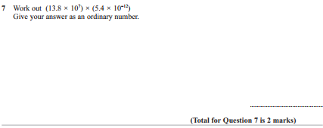
Pearson Edexcel - Thursday 25 May 2017 - Paper 1 (Non-Calculator) Higher Tier
2.
Pearson Edexcel - Thursday 25 May 2017 - Paper 1 (Non-Calculator) Higher Tier
3.
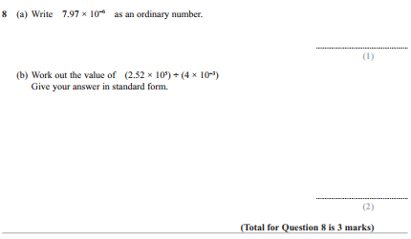

Pearson Edexcel - Specimen Papers Set 2 - Paper 1 (Non-Calculator) Higher Tier
4.
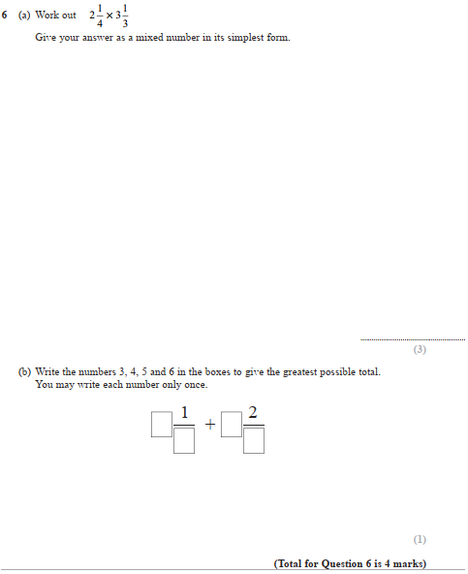

Pearson Edexcel - Sample Paper 1 - (Non-Calculator) Higher Tier
5.
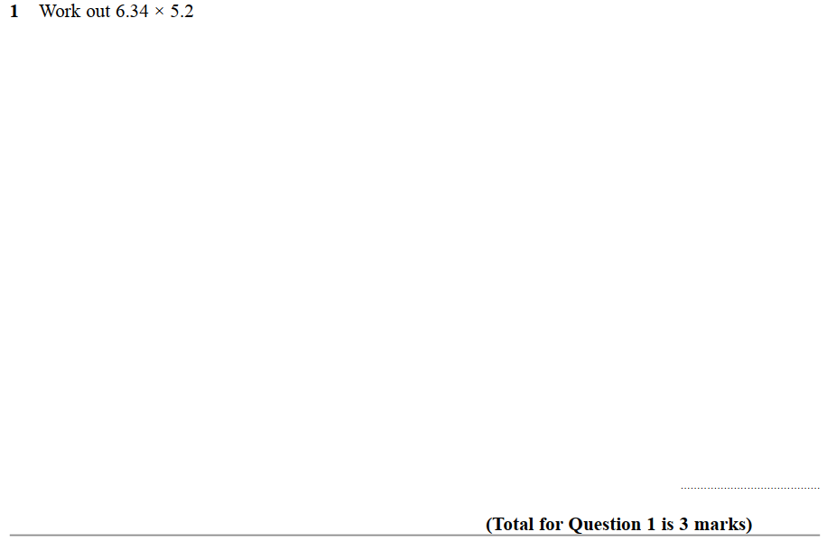
Pearson Edexcel - Thursday 26 May 2016 - Paper 1 (Non-Calculator) Higher Tier
6.
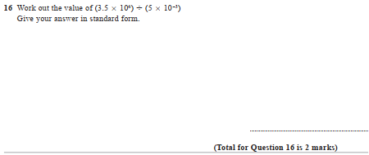

Pearson Edexcel - Thursday 26 May 2016 - Paper 1 (Non-Calculator) Higher Tier
7.
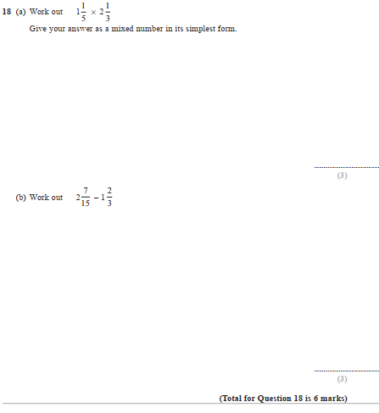
Pearson Edexcel - Wednesday 4 November 2015 - Paper 1 (Non-Calculator) Higher Tier
8.
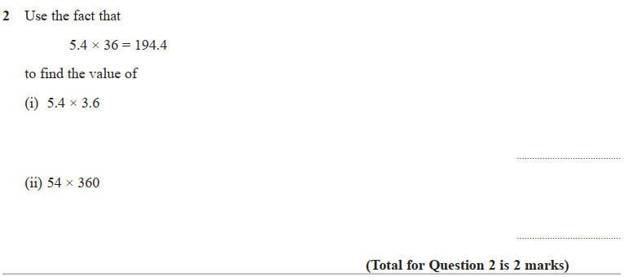
Pearson Edexcel - Wednesday 5 November 2014 - Paper 1 (Non-Calculator) Higher Tier
9.
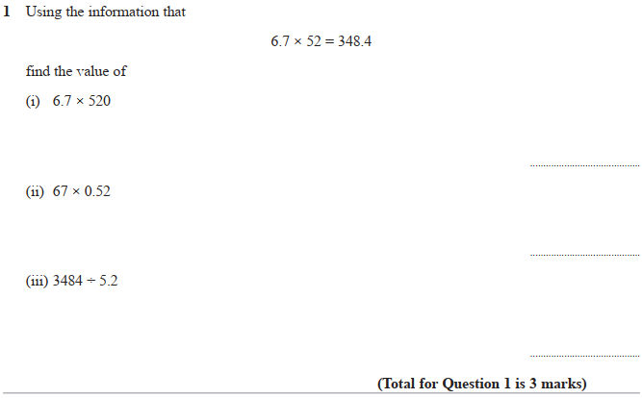

Pearson Edexcel - Tuesday 11 June 2013 - Paper 1 (Non-Calculator) Higher Tier
10.
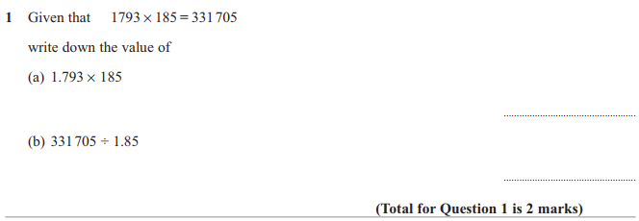

Pearson Edexcel - Thursday 28 February 2013 - Paper 1 (Non-Calculator) Higher Tier
11.

Pearson Edexcel - Monday 11 June 2012 - Paper 1 (Non-Calculator) Higher Tier
12.
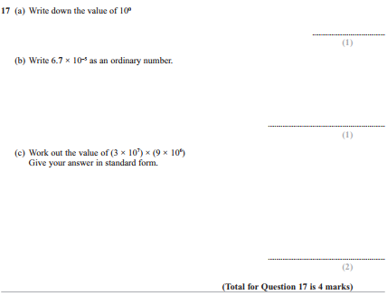

Pearson Edexcel - Friday 2 March 2012 - Paper 3 (Non-Calculator) Higher Tier
13.
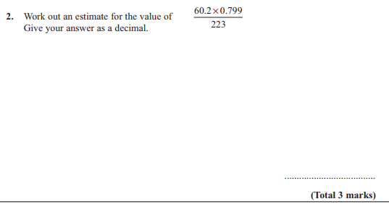

Pearson Edexcel - Friday 2 March 2012 - Paper 3 (Non-Calculator) Higher Tier
14.
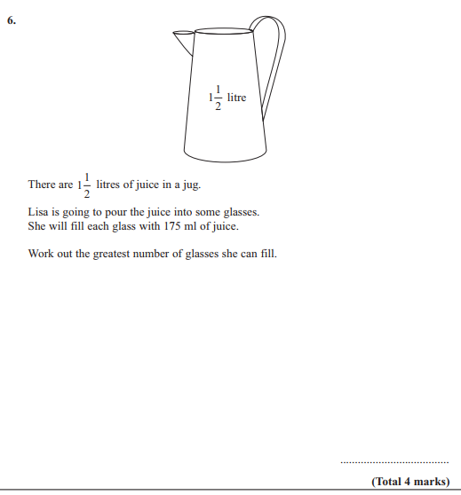

Pearson Edexcel - Friday 2 March 2012 - Paper 3 (Non-Calculator) Higher Tier
15.
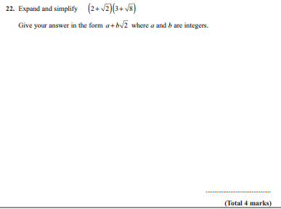

Pearson Edexcel - Tuesday 9 November 2010 - Paper 3 (Non-Calculator) Higher Tier
16.
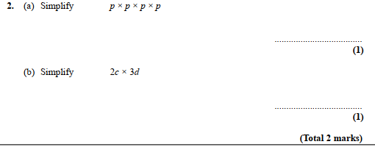

Pearson Edexcel - Monday 7 June 2010 - Paper 3 (Non-Calculator) Higher Tier
17.
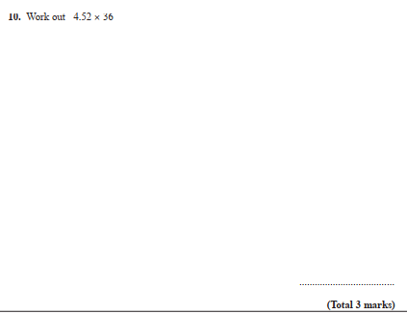
18.

